ACKNOWLEDGEMENT

“Fear of God is the Beginning of Wisdom”

It is a great pleasure to acknowledge with sincere gratitude all those who helped to make this project a success. First and foremost, we express our deep sense of gratitude to Almighty God, for his substantial blessings, which include unfailing strength, comfort, inspiration, and confidence to complete and bring the project to light.

Showing gratitude is not only a courtesy but also a duty. We express our respectful and sincere heartfelt thanks to our honorable secretary Rev. Dr. (Sr.) Niranjana Anthonisamy and our dynamic principal, Rev. Dr. (Sr.) A. Christina Bridget., M.Com., M.Phil., PGDCA, M.B.A, Ph.D., Holy Cross College (Autonomous), Tiruchirappalli-2, for providing us the opportunity and for kind encouragement. We also express our heartfelt thanks to the Vice Principals, Deans of Arts and Science for their moral support during the entire duration of this project.

We solemnly submit our honest and humble thankfulness to Dr. H. M. Leena, M.Sc., M.Phil., Ph.D., Head & Director – MCA, PG Department of Computer Science for her guidance, Enthusiastic encouragement, and suggestions for this project.

We are thankful for our lovable, caring, and respectful Class In-Charge and our project Guide Ms. S. Edel Josephine Rajakumari, M.C.A., M.Phil. with SET. for her patient guidance, encouragement, and useful critiques for this project. We would also like to thank for her kindness, corrections and encouragement.

Last but not least we would like to thank our parents and friends who appreciated our work and motivated us. Finally, we thank each other and everyone who helped us in some of the other ways towards the successful completion of the project.

MALINI S
JENIFER A
KAVYA JOAN A

CONTENT

CHAPTER  NO. | TITLE | PAGE NO.
 | ABSTRACT
 | LIST OF TABLES
 | LIST OF FIGURES
1. | INTRODUCTION
2. | KAVALAN APP  THEME  PURPOSE  OBJECTIVE  NEEDS OF SIGNIFICANCE
3. | SYSTEM STUDY  RESERCH METHODOLOGY  QUESTIONNAIRE DESIGN  DATA COLLECTION  LIMITATION AND FUTURE RESEARCH  TARGET PEOPLE  SAMPLE SIZE  OUTCOME
4. | SYSTEM ANALYSIS  OBJECTIVE OF THE SURVEY  DATA OF SURVEY  QUESTIONNAIRE  DATA EVALUTION
5. | CONCLUSION
 | BIBLIOGRAPHY

ABSTRACT

Women have the right to be free from violence, harassment and discrimination. Removing the barriers of an unsafe environment can help women fulfill their potential as individuals and as contributors to work, communities and economies. Women’s safety has become the utmost priority of the Indian government considering the increasing cases of crime against women. The main purpose of the Kavalan App is to protect the girl child from harassment. Nowadays only women, but many girls under the age of 14 are also being harassed. To recover them from that sort of dangerous problem, Our Tamil Nadu Government has implemented an app named KAVALAN to help those who face eve-teasing, sexual harassment, etc…

CHAPTER 1
INTRODUCTION

The Kavalan SOS app was launched by the Minister for Commercial Taxes and Registration, K.C. Veeramani, here on Tuesday, as part of the Tamil Nadu State Police Master Control Room initiative. The app was launched to extend instant help to people, particularly women, children, and senior citizens. Mr. Veeramani appreciated the police department’s efforts to harness technology. SOS app as part of the Tamil Nadu can use to seek police assistance instantly in emergencies such as floods, earthquakes, etc. This app is developed by Amtex Systems. There have been several instances of late when the Tamil Nadu police’s app, Kavalan SOS, has come in handy for users during an emergency. Be it harassment on the road or intrusion at home by strangers, the police have responded to those who used the app. While the app was launched in October 2018, downloads shot up after the 2019 Hyderabad rape incident. The police have also conducted several awareness programs in schools and colleges on the benefits of the app. So, what is the app all about? Read on to know more.

CHAPTER 2
KAVALAN SOS APP

Theme:
Women have the right to be free from violence, harassment and discrimination. Removing the barriers of an unsafe environment can help women fulfill their potential as individuals and as contributors to work communities and Economies . Women safety has become the utmost priority of the Indian government considering the increasing cases of crime against Women. There are various safety apps present on the play store designed for the protection and security of women.
Purpose:
The main purpose of Kavalan app is to protect the girl child from harassment. Now a Days not only women , many girls under the age of 14 are also being harassed. To recover them from that sort of dangerous problems, our Tamil Nadu government has implemented an app named Kavalan to help those who face eve teasing, sexual harassment etc…..
Objective:
The objective of the system is to provide a reliable security system for a women when they are alone or feel unsafe. In today’s date women face physical harassment in public places, schools and at workplace or while travelling. Most cases of physical harassment take place when women are alone or while travelling. Women and the elderly can press the panic button or just wave their mobiles thrice to send and SOS to the police control room and help will be sent to their location. Once the person in distress triggers an alert staff in the control room which is manned by a private form receives a message and pass in on to police officers. The police locate the nearest petrol vehicle, police officer police station to reach out to the victim. The call center staffs also alert close relatives or family members if numbers are available. During emergency, pressing the SOS button on the home page will automatically send the current location of the person in trouble along with a video to the Kavalan team. Within a minute, the team will contact the person. Simultaneously, the location will also be sent pre-registered emergency contacts as SMS alerts.
Needs and significance:
The main need of this app is to increase the protection of women. The app is the state police’s master control room initiative’ which people can use to seek police assistances instantly during emergencies such as eve-teasing, kidnapping or women and senior citizen to alert the police if they were in distress.

CHAPTER 3
SYSTEM STUDY

Research Methodology:
To measure these objectives, empirical data had to be collected and later be used for analyzing and finding the results. In order to gather the empirical data, a questionnaire had to be designed as explained in detail in the next page.
Questionnaire Design:
The first stage involved a review of the literature and Feedback from experts in the area of interest to obtain information and find out how other researchers previously did their studies then;empirical data was with open collected from people to achieve the research objectives. Based on the research objectives, a sample questionnaire mainly with open ended question was initially developed. After revisions, a final questionnaire was developed to collect the data.
Data Collection:
- Tool:Google Form
- Collection method:Questionnaires
Research data was gathered by utilizing a structured questionnaire. The total sample size was fixed at 100 usable responses for analysis. The data was collected by the people who are at various places. To ensure all questions are being answered in a proper way, questionnaires were completed one-by-one and carefully reviewed before the next respondent.
Limitation and Future Research:
Although this research is primarily based on the primary data from the people and middle-aged people, the finding cannot be generalized, as the research is based on Non-probability sampling. This study has successfully examined reviews about the safety measures of kavala app.
Target People:
The main target of this app is women. It is especially developed for the women to seek immediate assistance in emergency situations such as sexual harassment, kidnapping and also during natural disasters. Target people Tamil Nadu: Woman uses 'Kavalan App' For reporting sexual harassment, police Nabs Three.
Sample Size:
We've took a survey from people by using google forms. We are expecting nearly 100+ response. By collecting those response we will actually get to know how many people are aware of women safety and also about kavalan app. More than 1Million people have downloaded kavalan app for their safety measures. This survey is not only taken to know how many people use this app, but also, it is taken for further technical improvement that can be implemented for the development of this app.
Outcome:
The app has been working with great pleasure. There are nearly 1M downloads in play store, so most of the population have great trust and Confidence about this app. Even though there are many implementation are to be done but this app performs well and good in each and every update.

CHAPTER 4
SYSTEM ANALYSIS

Objectives of the Survey:
The main objective of the survey:
- To find out the safety measures of Kavalan app.
- To find out the awareness among people.
Working method of SOS:
An SOS button will be visible on the home page. Upon pressing it, a five second countdown will begin. At the end of the Countdown, the app will send the user's current location, along with a panic signal and a video recording from the back camera to the police control room. Call receivers at the master control room will alert a team of police personnel. The personnel will review the call and alert the relevant control room, police station or patrol team, who will reach out to the victim. The service is available 24×7.After downloading the app, you have to register by providing some basic information about you.
Personal Mobile Number Home Address Alternate Mobile number E-mail Address Date of Birth Gender Details such as Mobile number, Name & Relationship of any two relatives or close friends as emergency contacts, preferably living in the same city. Additionally, a third contact as an emergency contact may also be added.
After entering the above details, you will receive an activation code on your registered mobile number. Please enter your activation code to complete the registration process. The Kavalan app home screen will be displayed on you mobile phone.
Downloading Method:
Residents of Tamil Nadu can download the app. The police especially encourage women and the elderly to use the app. Android and iOS versions of the app are available.
Seek Details:
Users must provide their mobile phone number, address, date of birth and gender to register. The app seeks a wide range of permissions to make and manage phone calls, access contacts, view SMS messages, take pictures, record video and audio, view device location and access photos and files.
Secured Data:
While there have been concern over the safety of user details, the police have clarified that the details are gathered only to reach out to the users and the data will be stored securely.

Data of Survey:
The survey is collected through Google forms from 100 people in our specific area such as women, college students, working women, Working Men.

No | Name | Gender | Designation
1 | JESSICA.K.M | Female | Student
2 | A.Nancy Esthar | Female | Student
3 | E. Aarthi Juvanitta | Female | Student
4 | Kavya Joan A | Female | Student
5 | Josephine Rani V | Female | Student
6 | Sivasangari G | Female | Student
7 | T Deepalakshmi | Female | Student
8 | Divya.B | Female | Student
9 | P.Gayathri | Female | Student
10 | Dhivyabharathi C | Female | Student
11 | L.Basti abitha | Female | Student
12 | Dafny kiruba. J | Female | Student
13 | Gayathri. M | Female | Student
14 | Josphin | Female | Student
15 | Deepthi shree.N | Female | Student
16 | Deepa.T | Female | Student
17 | Dinesh | Male | Working Men
18 | Naveena.P | Female | Student
19 | C.JANANI | Female | Student
20 | R.Priyadharshini | Female | Student
21 | ARUNKAVIYARASAN S | Male | Student
22 | Janani.A | Female | Student
23 | A.saranya | Female | Student
24 | Sariga saravana kumar | Female | Student
25 | Neha | Female | Student
26 | J Agathiya | Female | Student
27 | N.Ramya | Female | Student
28 | Sipriyan | Male | Student
29 | Jothiga | Female | Student
30 | Ajith Michael | Male | Student
31 | Ajith | Male | Student
32 | Isabella | Female | Student
33 | Arockia swetha .R | Female | Student
34 | Vasanth Kumar D P | Male | Student
35 | Vasanth Kumar D P | Female | Home maker
36 | A.Rema malar | Female | Student
37 | Divya | Female | Student
38 | Rabina.JK | Female | Student
39 | CLATROUIES I | Male | Student
40 | Williams A | Male | Student
41 | Malini S | Female | Student
42 | Praveena A | Female | Student
43 | Showmiya | Female | Student
44 | V.N.KEERTHANA | Female | Student
45 | Fazila | Male | Student
46 | M. Geetha piriya | Female | Student
47 | R.Jancy Igneshia | Female | Student
48 | Planson wright | Male | Student
49 | Jeya Pradheep | Male | Student
50 | Jeya Pradheep | Male | Student
51 | E. Dharshna sherli | Female | Student
52 | R.Indra Ruby | Female | Student
53 | Jenifer.A | Female | Student
54 | A.Jenifer | Female | Student
55 | Joe Kevin.A | Male | Student
56 | Suromiya.P | Female | Student
57 | Karthick.B | Male | Student
58 | A.Dasline Varsha | Female | Student
59 | Arul Shilpa.A | Female | Student
60 | Shilpa.A | Female | Student
61 | Jesintha mary.A | Female | Working Women
62 | RINCY MARGRET A | Female | Student
63 | Joan. A | Female | Student
64 | J. celsia | Female | Student
65 | A.Janet jacklin jayanthi | Female | Home maker
67 | BHAVANI SANKAR G | Male | Working Men
68 | K.vimal | Male | Student
69 | Jofona | Female | Student
70 | Ranjitha | Female | Working Women
71 | Ashok. J | Male | Home maker
72 | Idhaya K | Female | Working Women
73 | Akshaya S | Female | Working Women
74 | Maria Rachel | Female | Student
75 | Perezhil pradhap singh.A | Male | Student
76 | A. Nesana | Female | Student
77 | Mariya Delphi L | Female | Student
78 | A.Merlin lovi shairai | Female | Student
79 | Ashika.I | Female | Student
80 | Brijit.I | Female | Student
81 | Elisinamerlin.A | Female | Student
82 | PHILOMINAL.P | Female | Student
83 | Kavya | Female | Student
84 | Joan A | Female | Student
85 | Sara | Female | Student
86 | Samson Raj J | Male | Student
87 | Keerthan | Male | Working Men
88 | J.Ayesha begum | Female | Student
89 | G.Divyasri | Female | Student
90 | E. Dharshna sherli | Female | Student
91 | John Britto | Male | Working Men
92 | Denci.R | Female | Student
93 | Dersitta Nathan S | Female | Student
94 | Selcia Mary R | Female | Student
95 | Harshini G | Female | Student
96 | Harshu S | Female | Student
97 | Ganesan.A | Male | Student
98 | Nehru.i | Male | Student
99 | Ajithkumar.k | Male | Student
100 | Jency helan.L | Female | Student
101 | Durgadevi.B | Female | Student

QUESTIOARIES:
Study on Kavalan App:
1. Do you know about the Kavalan SOS App?
A. Yes B. No C. No idea

2. Have got registered in this Kavalan SOS App?
A. Yes B. No C. No idea

3. Do you think Kavalan SOS App is useful for women's safety?
A. Yes B. No C. No idea

4. How far SOS is Working?
A. Good B. Average C. Bad

5. Can the Kavalan App be used by Everyone?
A. Yes B. No C. No idea
+
6. Is the Kavalan app used by all women?
A. Yes B. No C. No idea

7. Will Kavalan App give confidentiality to your data?
A. Yes B. No C. No idea

8. Who suggests it to you?
- Neighbors B. SocialMedia
C. Parents D. Friends

9. Do you feel happy to use this app?
A. Yes B. No C. Not at all

10. Are you feeling safe while using this app?
A. Yes B. No C. Not at all

11. Do you think any changes have to be taken in the Kavalan app?
A. Yes B. No C. Not at all

12. Your emergency is understood by the police?
A. Agree B. Strongly Agree C. Neutral
D. Disagree E. Strongly Disagree

13. Do they ask for more details while you meet the emergency?
A. Yes B. No C. Not at all

14. Will you suggest or recommend this app to others?
A. Yes B. No C. Not at all

15. Kavalan SOS is used while we are in danger.
A. Yes B. No C. Not at all

16. However it is a bisexual used app, it is mostly used for women.
A. Agree B. Strongly Agree C. Neutral
D. Disagree E. Strongly Disagree

17. As part of this government scheme, the police give an instant response.
A. Agree B. Strongly Agree C. Neutral
D. Disagree E. Strongly Disagree

18. We can go alone and we can get protection in Kavalan SOS App?
A. Agree B. Strongly Agree C. Neutral
D. Disagree E. Strongly Disagree

19. Kavalan SOS is a very secure app
A. Agree B. Strongly Agree C. Neutral
D. Disagree E. Strongly Disagree

20. People in the city are more aware than the people in the village.
A. Agree B. Strongly Agree C. Neutral
D. Disagree E. Strongly Disagree

21. Kavalan SOS must be implemented through new technology other than the mobile phone for the usage of all people.
A. Agree B. Strongly Agree C. Neutral
D. Disagree E. Strongly Disagree

22. It can be used 24/7 at any time anywhere.
A. Agree B. Strongly Agree C. Neutral
D. Disagree E. Strongly Disagree

23. What is your feedback about this app?
--------------------------------------------

24. Record your opinion while using this app?
--------------------------------------------------

25. Rate these Kavalan SOS App.
1 2 3 4 5

DATA EVALUATION:

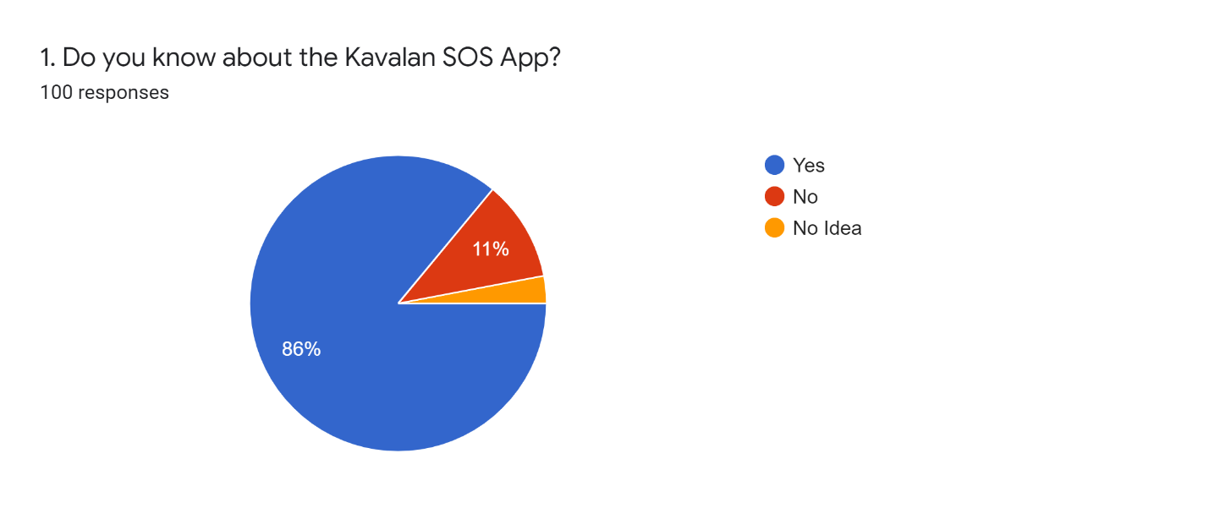

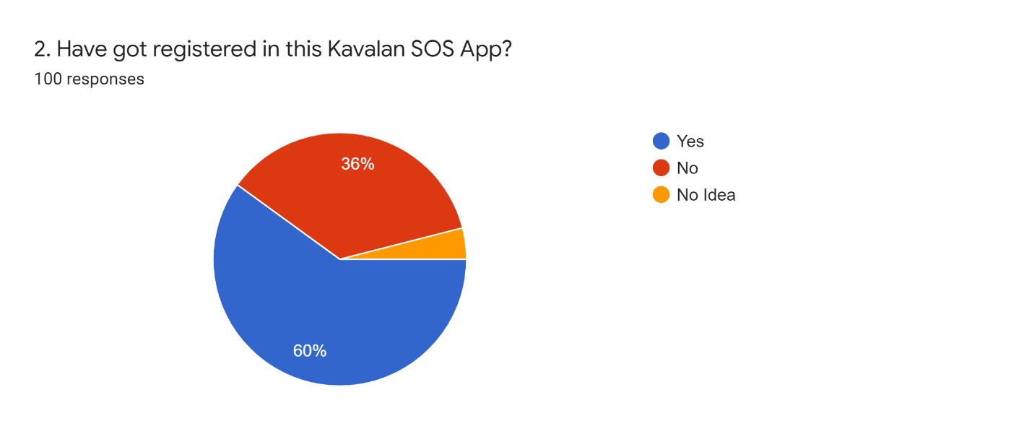
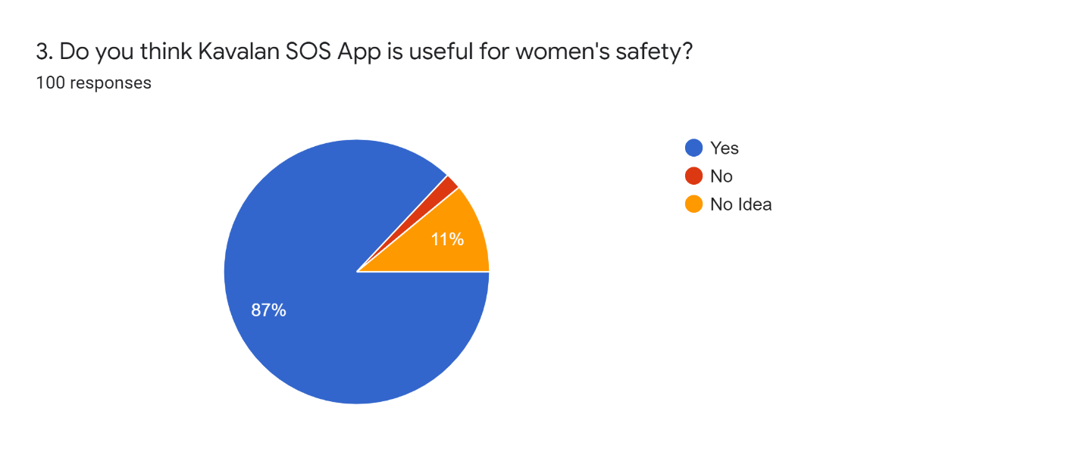
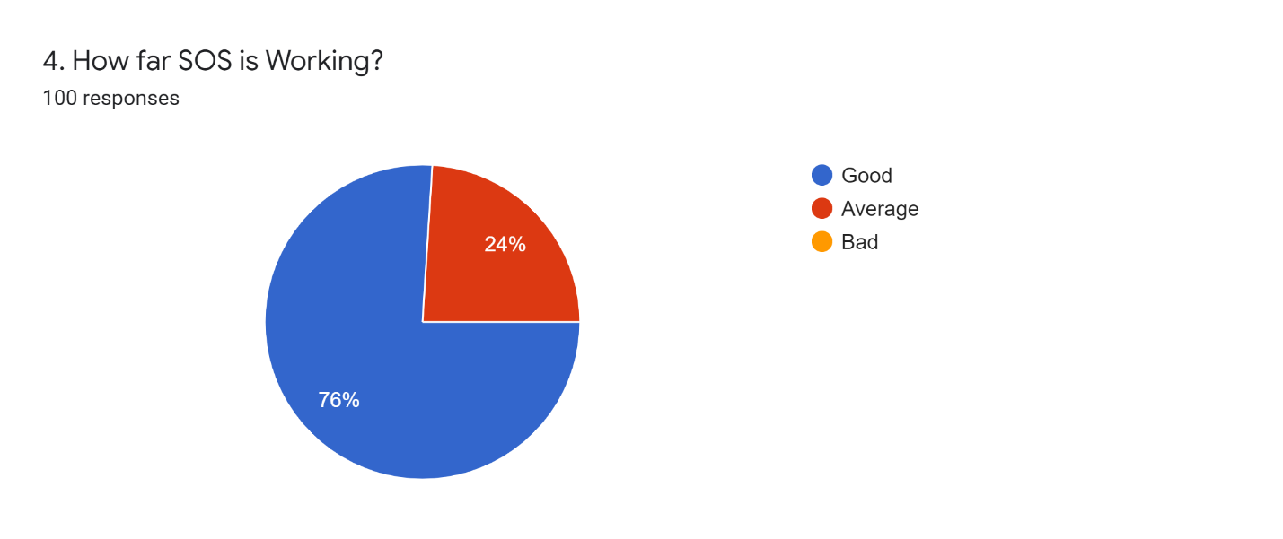
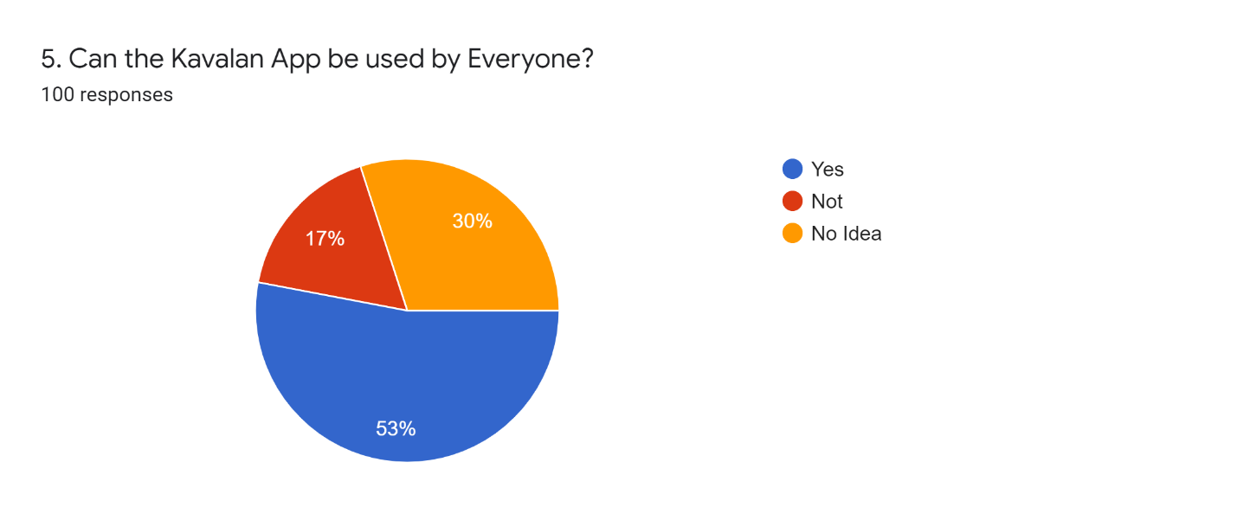
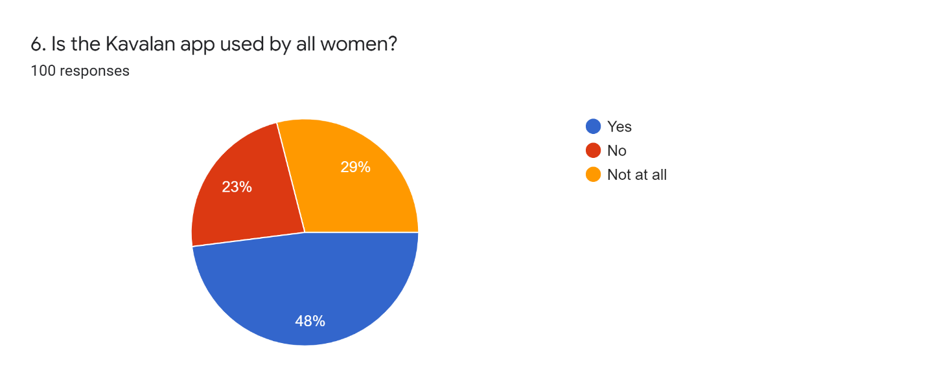
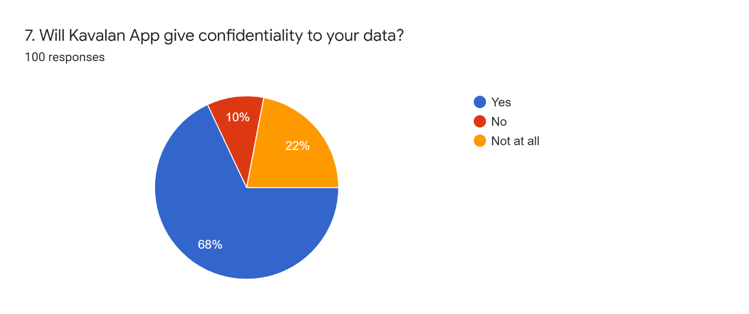
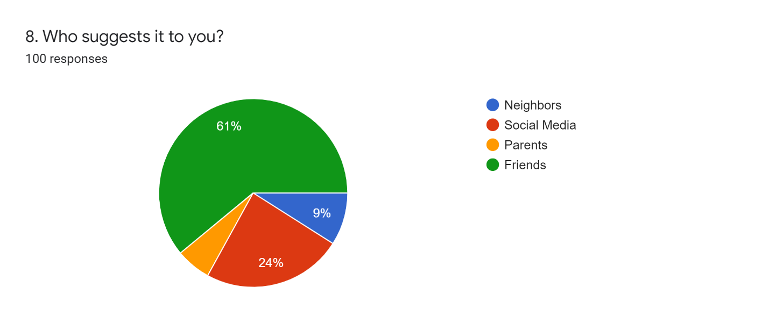
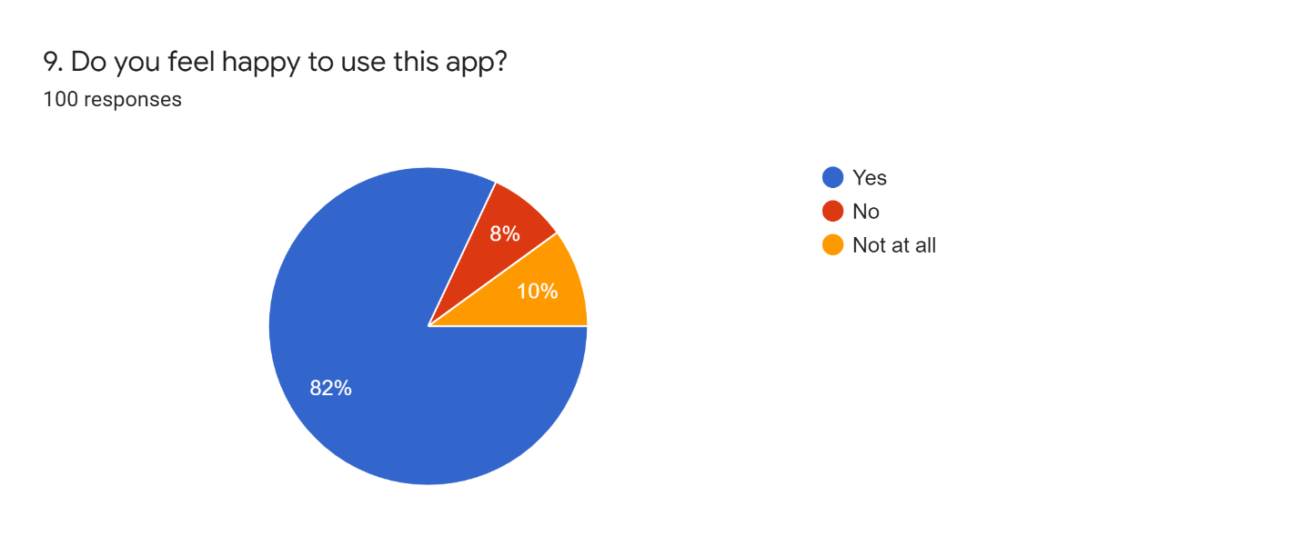
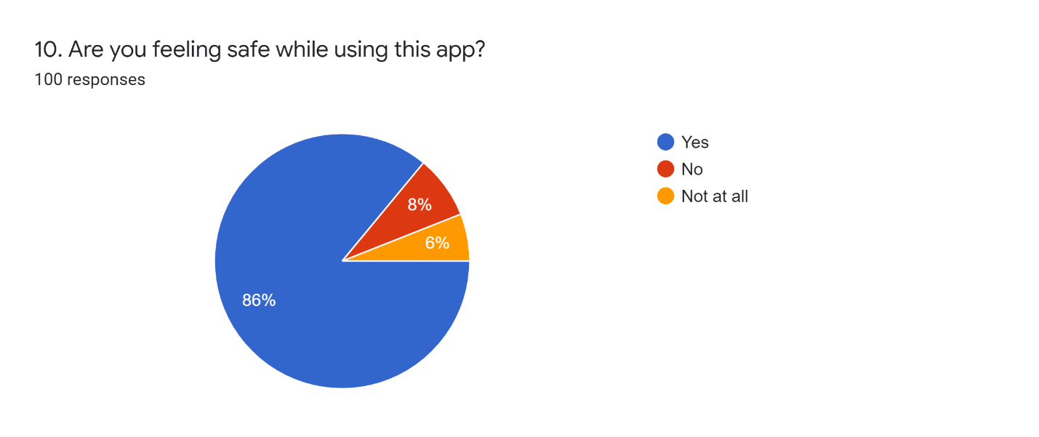
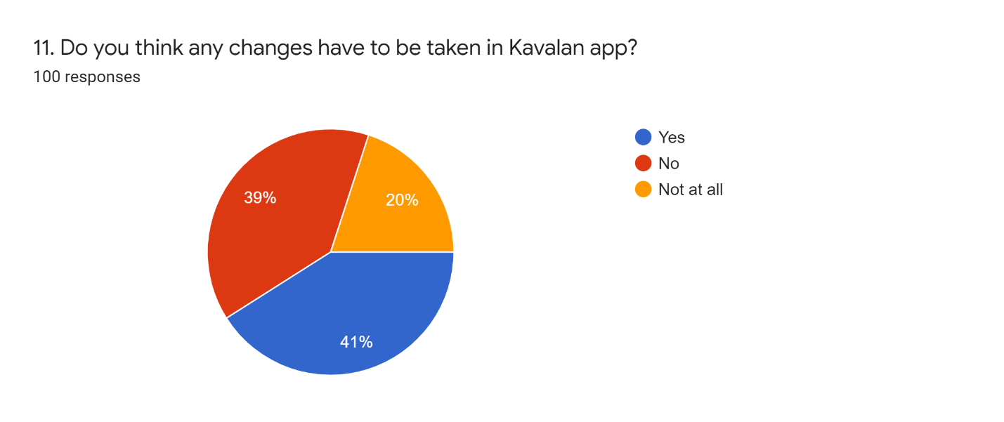
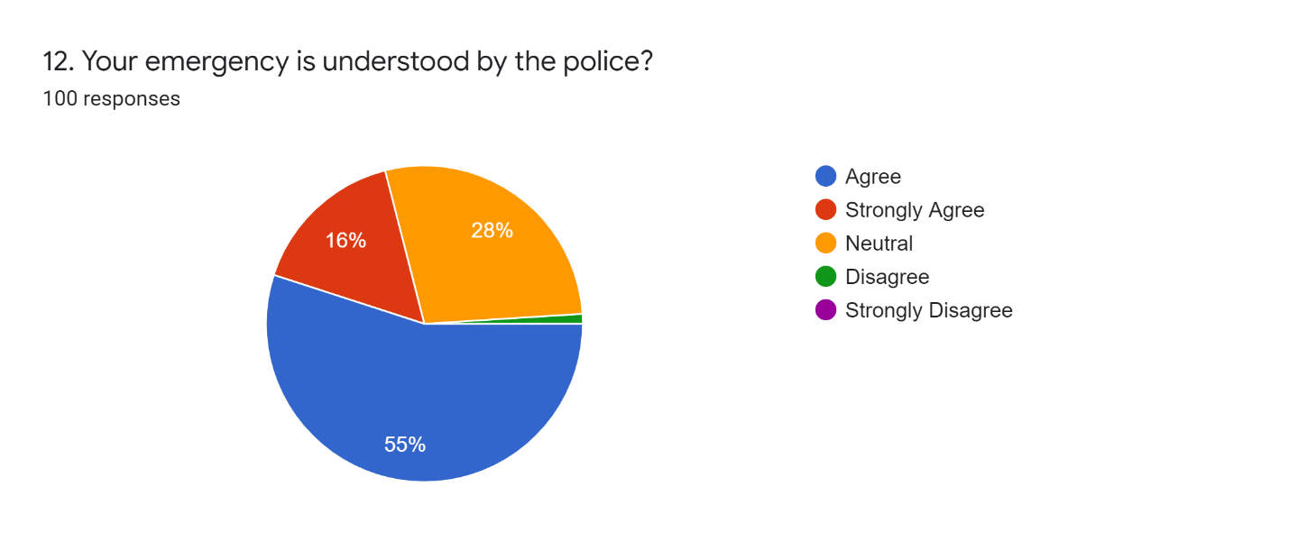
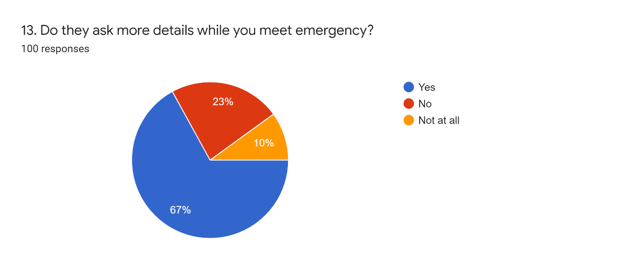
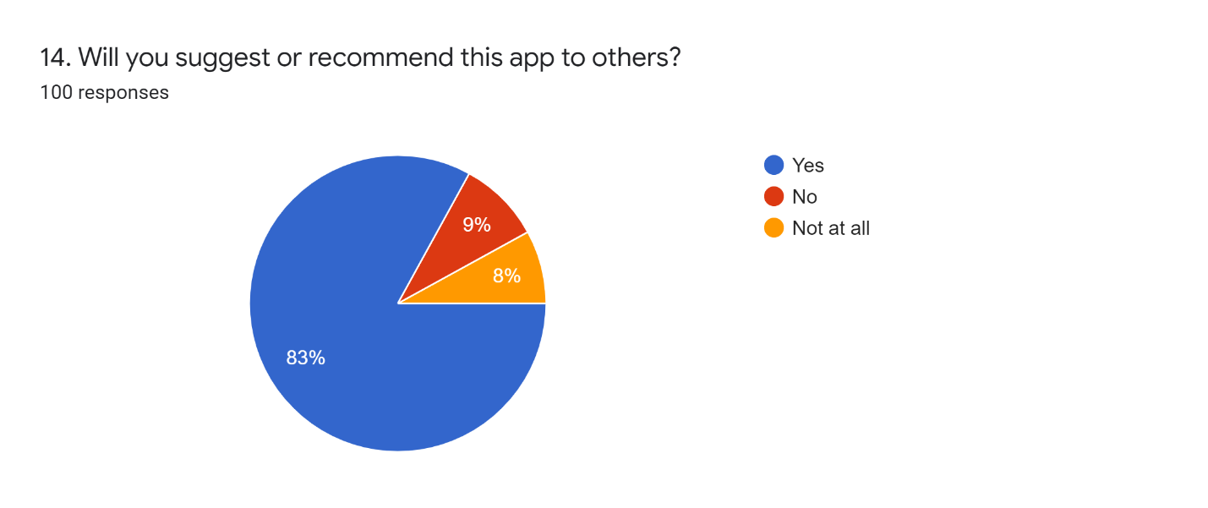
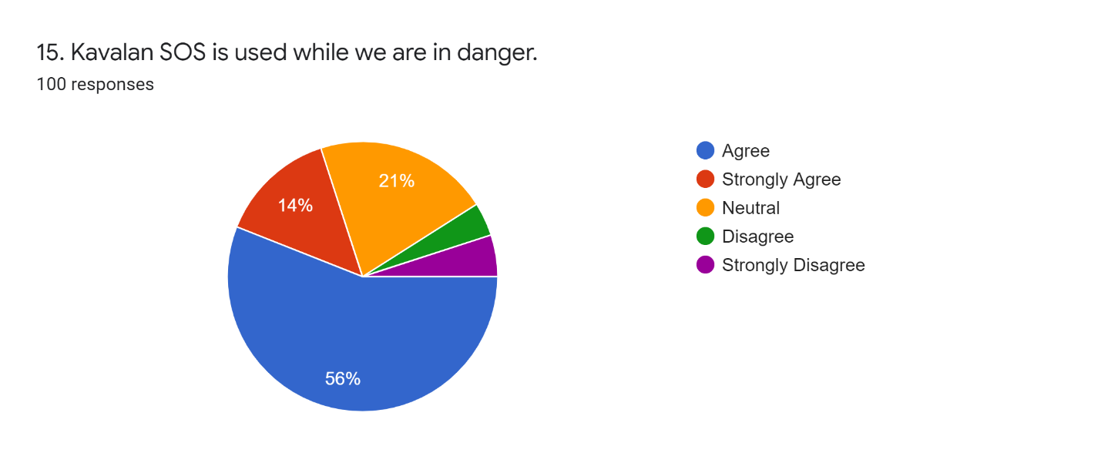
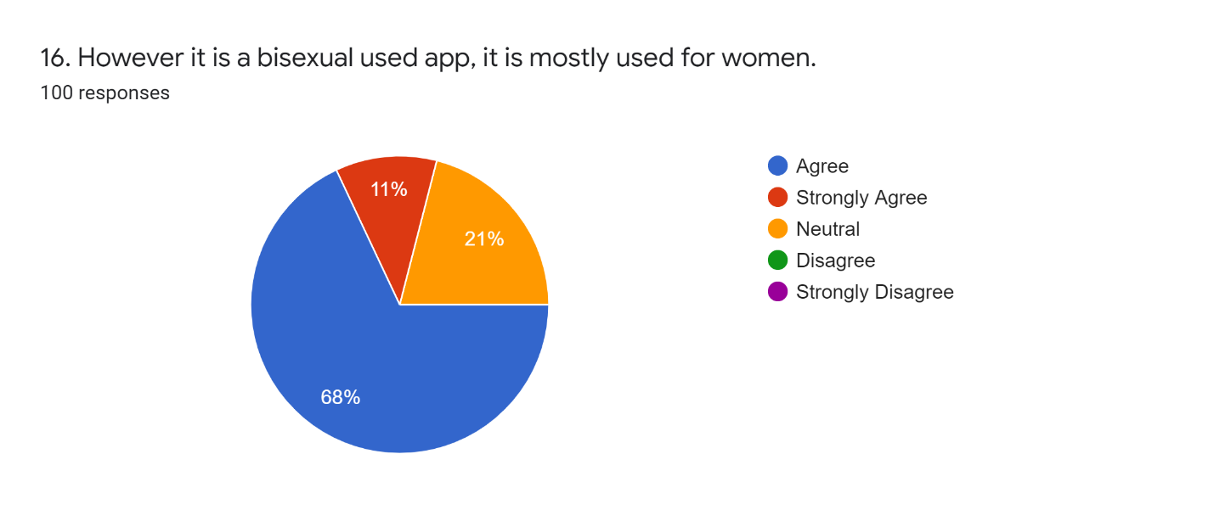
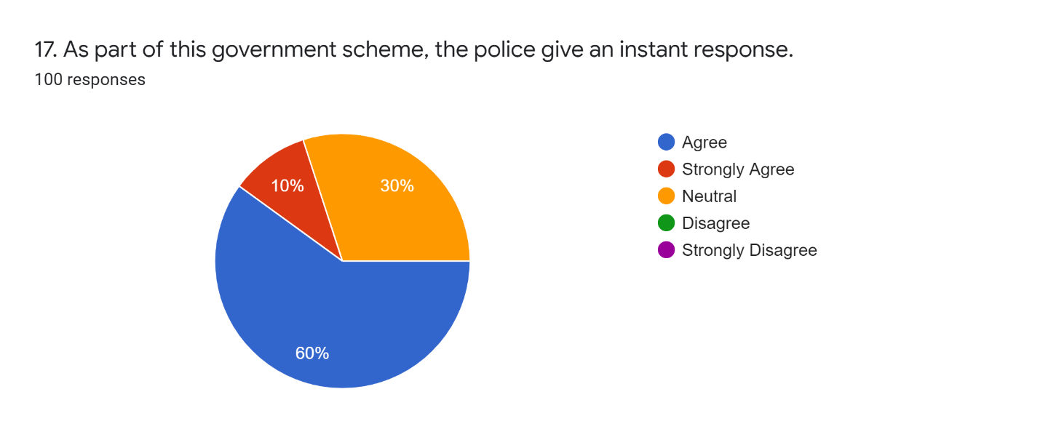
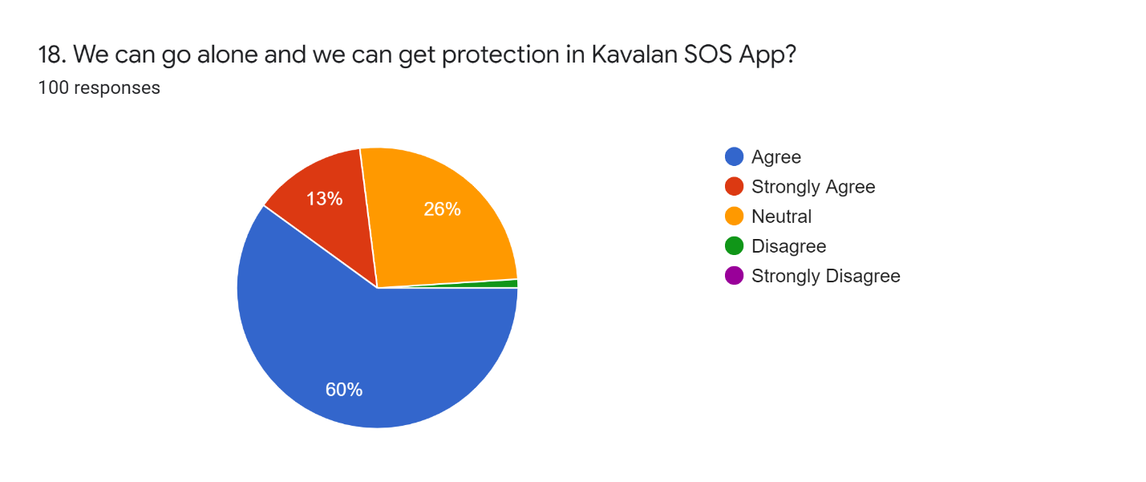
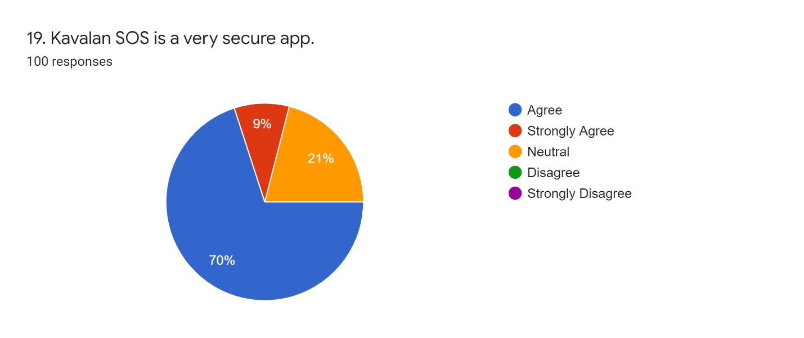
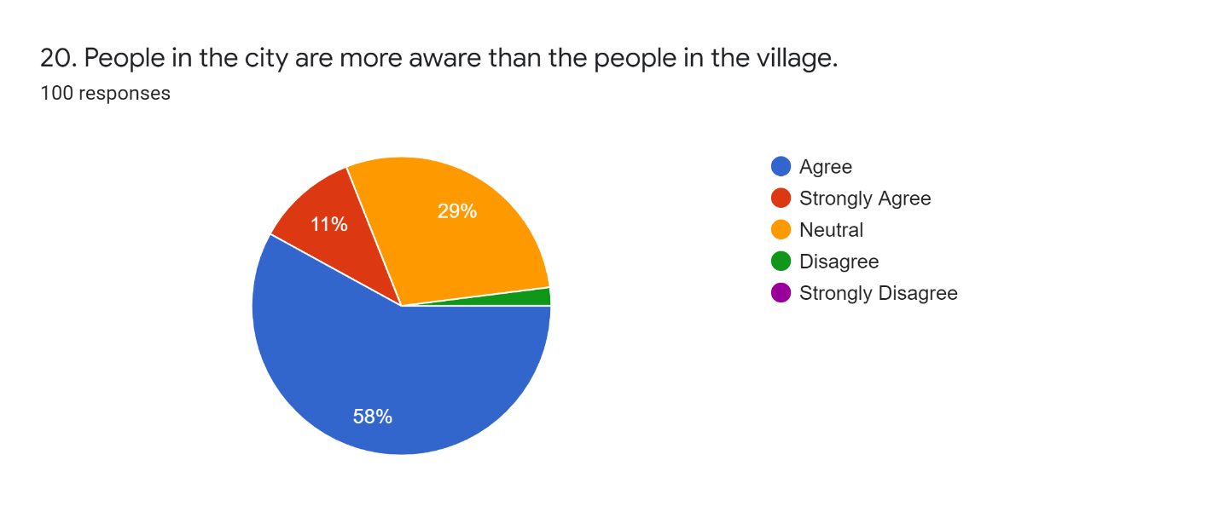
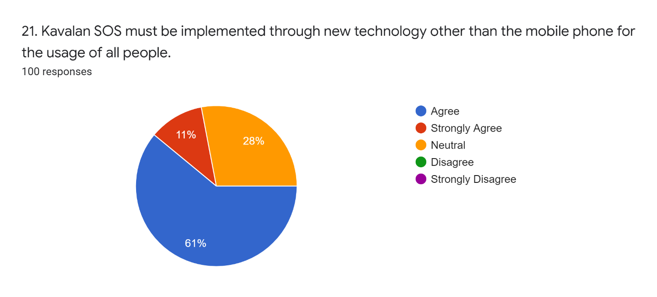

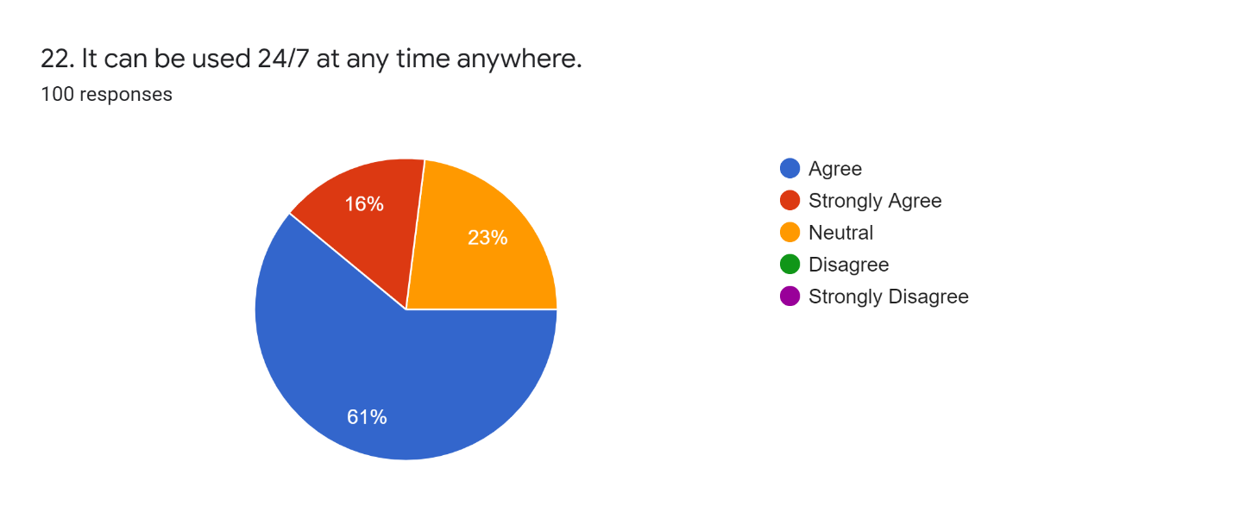
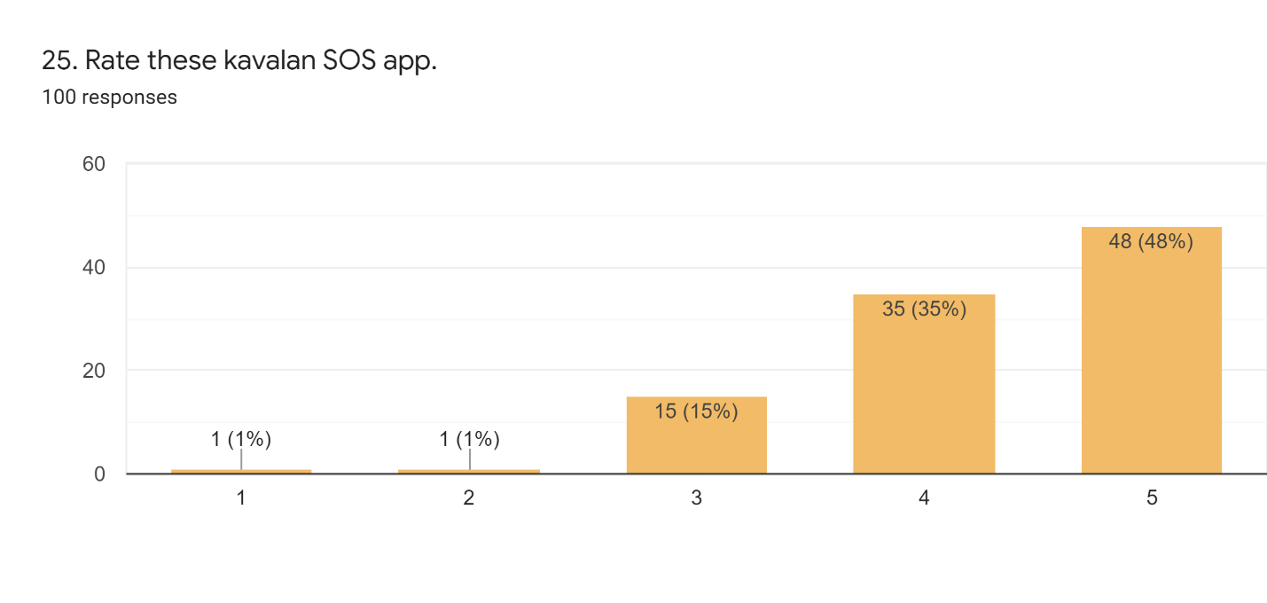

CHAPTER 5
CONCLUSION

Therefore, by the response we got from a survey, People say that this app performs pretty well. There are many positive responses from the users that this app helps them a lot. And also, many people around Tamil Nadu are aware of this app.

BIBLIOGRAPHY
WEB REFERENCES

- https://play.google.com/store/apps/details?id=com.amtexsystems.kavalansos&hl=en_IN&gl=US
- https://www.youthapps.in/2018/08/kavalan-sos-tamil-nadu-police-mobile-app.html
- https://turcomat.org/index.php/turkbilmat/article/download/1751/1497/3275
- https://www.newindianexpress.com/cities/chennai/2021/apr/27/kavalan-sos-app-to-prevent-crime-2295311.html
- https://www.ijeter.everscience.org/Manuscripts/Volume-8/Issue-2/Vol-8-issue-2-M-03

